Understanding patient indicator badges
NOTE: Images in this document are a visual representation only. Your system view may appear slightly different.
The patient indicator badges appear on the patient banner and cards where information is located. These provide abbreviations of the types of visits and number of information listed in the past 12 months.

 | View the patient indicator badges.
 | Understand the meaning of the indicator your viewing.
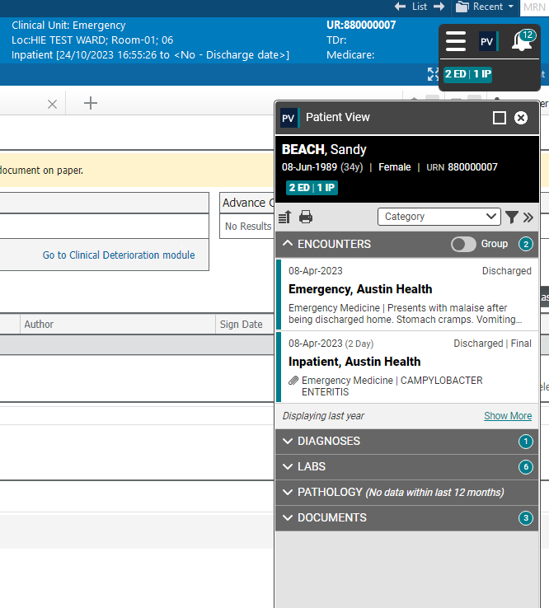
1
2

Badge | Definition
 | Emergency Department |  | The ED and IP badges appear if the patient has a hospital visit of these types within the past 12 months including any current presentations/admissions
 | Inpatient
 | Discharge | If the patient was discharged within the last 30 days, the indicator displays DC and the number of days since the discharge date.  If the patient was discharged within the last 30 days but was readmitted (inpatient encounter) within the 30 days, the indicator displays READMIT instead of DC.  If the patient was discharged more than 30 days ago, no status is shown for discharge.
 | Protected Patient |  | Upon `Breaking glass’ the VIP badge will be visible on the Patient Banner as per the ED and IP badges.

