NOTE: Images in this document are a visual representation only. Your system view may appear slightly different.

Understanding Break Glass protection

The Break Glass function enables designated authorised users to access patient record with sensitive information (protected patient).
2
Steps to Break Glass
 | When you click on the CareSync Exchange button on the menu, a padlock will be displayed next to the name within CareSync Exchange  The Break Glass message will also display if authorised to break glass.  Clinicians without access to protected patient records will receive a Patient Access Denied message. | 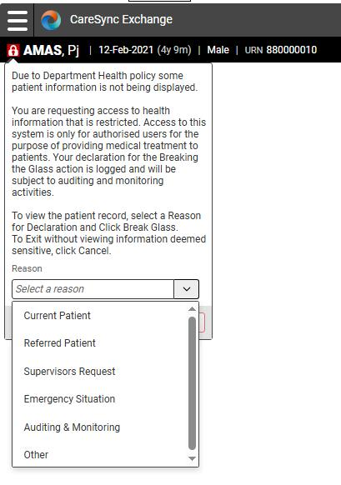  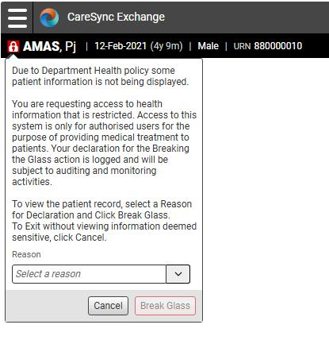  1
 | Read the Break Glass message, and if proceeding, click the drop-down arrow to select your reason for accessing the record.  If selecting Other, you will need to provide additional commentary for the reason.    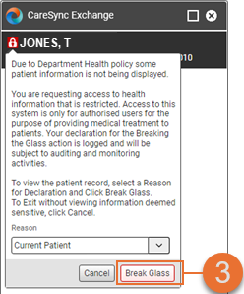  Once reason is selected, the Break Glass button becomes available. Select and access the CareSync Exchange patient record.  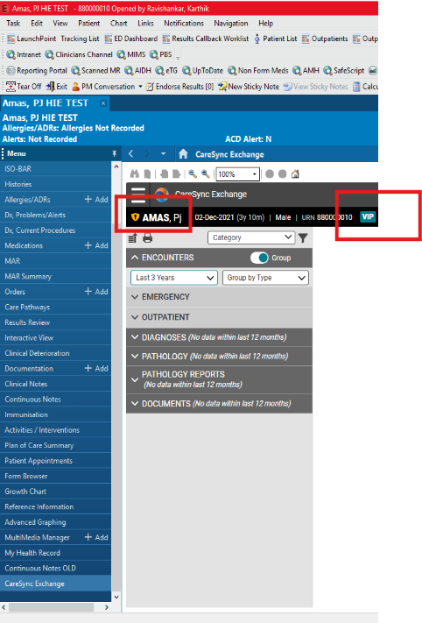  4  4  Once break glass has been achieved a yellow confidential shield will appear next to the patient’s name

Note: Break glass will need to be performed each time the CareSync Exchange record is accessed by the authorised user.

